The Survival of Gray Wolves Lab

Before the arrival of European settlers, wolves ranged widely across the continent, from coast to coast and from Canada to Mexico. Two species are found in North America, the gray wolf, with its various subspecies, and the red wolf, found in the southeastern United States. Wolves play an important role as predators in the ecosystems they inhabit. They feed primarily on large mammals, such as deer and elk, removing sick and injured animals from the populations. Wolves are highly social, living in packs and hunting and raising young cooperatively.

As the country was settled, native prey species declined and the number of domestic animals

increased. As wolves increasingly turned to livestock for prey, government agencies and private

citizens undertook large-scale predator control programs, with wolves hunted nearly to extinction.

By the middle of the 20th century, few wolves existed in the lower 48 States. Only several hundred gray wolves in Minnesota and an isolated population on Michigan’s Isle Royale remained, along with an occasional Mexican wolf— and reports of a few red wolves.

Thanks to recovery programs and to the natural migration from Canada into Montana, more than 5000 gray wolves now live in the lower 48 States.

Source: “Wolf Recovery in North America.” U.S. Fish and Wildlife Service, January 2007

Objective

You will gain an understanding of the impact human activities can have on the survival of a gray wolf population over 10 years by recording and graphing the changes in the population numbers of a gray wolf pack with and without human interference.

Procedure

1. Google “online dice roller” and select two dice.
2. Your population of wolves begins with 2 breeding adults and 6 pups, for a total of 8 wolves. For each generation of wolves, roll the dice to determine what happens to the population numbers.For each roll, add the numbers together and record the total in the “Dice Roll” column on the answer sheet. If you roll doubles, record them as “2s,” “3s,” “4s,” and “5s.”
3. Each dice combination is listed in the “Gray Wolf Population Changes” tables. Use your dice roll and Table 1 to complete the “Change in Population WITH Human Interference” column.
4. Calculate the “Total # of Wolves” column by adding and/or subtracting the numbers from the “Reproduction & Migration” and “Change in Population WITH Human Interference” column. Remember that you begin with 8 wolves in your population.
5. What would happen to this wolf population if there weren’t any humans involved? To find out, repeat steps 2 and 3 using Table 2 to complete the ”Change in Population WITHOUT Human Interference” and second “Total # of Wolves” column.

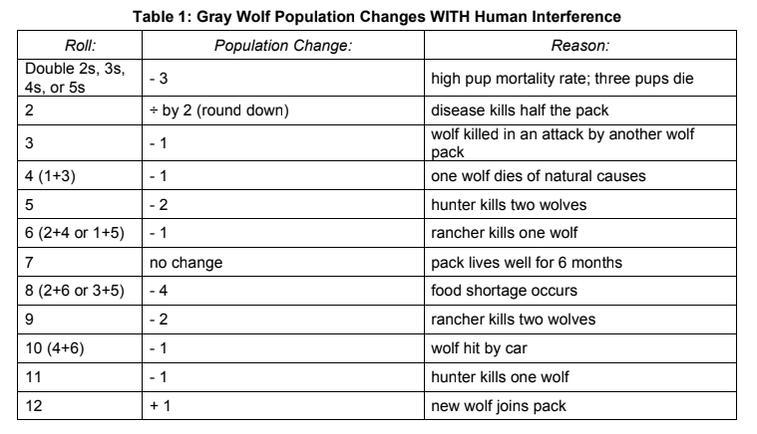

| Time | Reproduction and Migration | Dice Roll | Change in population **WITH** human interference | Total number of Wolves |
| --- | --- | --- | --- | --- |
| 0 Months | 8 wolves | | | |
| 6 months | +3 | 5 | -2 | 9 |
| 1 year | +3 | 9 | -2 | 10 |
| 1.5 years | +3 | 5 | -2 | 11 |
| 2 years | +3 | 9 | -2 | 12 |
| 2.5 years | -2 | 6 | -1 | 9 |
| 3 years | +3 | 6 | -1 | 11 |
| 3.5 years | +3 | 11 | -1 | 13 |
| 4 years | -1 | 9 | -2 | 10 |
| 4.5 years | +3 | 8 | -4 | 9 |
| 5 years | +2 | 5 | -2 | 9 |
| 5.5 years | +3 | 12 | +1 | 13 |
| 6 years | -1 | 12 | +1 | 13 |
| 6.5 years | +3 | 8 | -4 | 12 |
| 7 years | +3 | 10 | -1 | 14 |
| 7.5 years | +3 | 10 | -1 | 16 |
| 8 years | +3 | 7 | 0 | 19 |
| 8.5 years | -2 | 5 | -2 | 15 |
| 9 years | +2 | 8 | -4 | 13 |
| 9.5 years | +3 | 10 | -1 | 15 |
| 10 years | +3 | 8 | -4 | 14 |

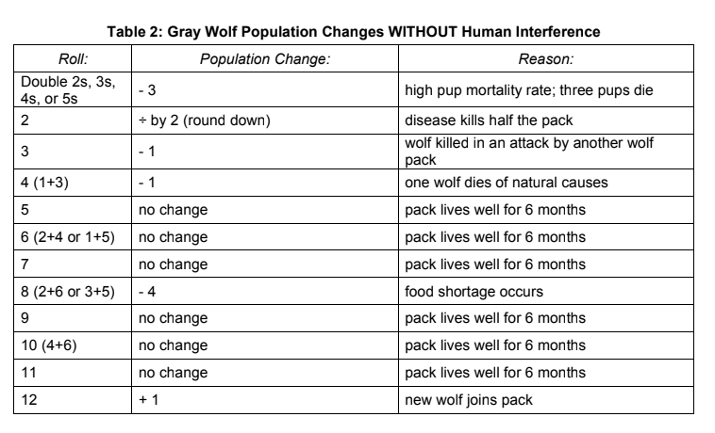

| Time | Reproduction and Migration | Dice Roll | Change in population **WITHOUT** human interference | Total number of Wolves |
| --- | --- | --- | --- | --- |
| 0 months | 8 wolves | | | |
| 6 months | +3 | 12 | +1 | 12 |
| 1 year | +3 | 6 | 0 | 15 |
| 1.5 years | +3 | 7 | 0 | 18 |
| 2 years | +3 | 4 | -1 | 20 |
| 2.5 years | -2 | 4 | -1 | 17 |
| 3 years | +3 | 3 | -1 | 19 |
| 3.5 years | +3 | 5 | 0 | 22 |
| 4 years | -1 | 6 | 0 | 21 |
| 4.5 years | +3 | 10 | 0 | 24 |
| 5 years | +2 | 9 | 0 | 26 |
| 5.5 years | +3 | 11 | 0 | 29 |
| 6 years | -1 | 4 | -1 | 27 |
| 6.5 years | +3 | 10 | 0 | 30 |
| 7 years | +3 | 7 | 0 | 33 |
| 7.5 years | +3 | 3 | -1 | 35 |
| 8 years | +3 | 7 | 0 | 38 |
| 8.5 years | -2 | 5 | 0 | 36 |
| 9 years | +2 | 4 | -1 | 37 |
| 9.5 years | +3 | 11 | 0 | 40 |
| 10 years | +3 | 12 | +1 | 44 |

**Please write in complete sentences:**

1. What are two **biotic** factors that affect the gray wolf population? One biotic factor that can affect the gray wolf population is disease. The second biotic factor that can affect the gray wolf population is a predation.
2. What are two **abiotic** factors that affect the gray wolf population? One abiotic factor that can affect the gray wolf population is temperature. The second abiotic factor that can affect the gray wolf population is behavior.

1. Write a 6 sentence summary/conclusion of what you found out during this activity. One thing I found was that humans almost kill all the grey wolves. That happened when the government agencies undertook large-scale predator control programs, and wolves almost went extinct. The second thing I found was humans helped restore the population of grey wolves by protecting them. Now more than 5000 gray wolves live in the lower 48 States. The third thing I found was wolves killed domestic animals and livestocks. The reason why they did this is because native prey species declined and the number of domestic animals increased.
2. Do you believe this activity accurately models the changes that occur within the gray wolf population of North America? Why or Why not? Yes I believe that this activity accurately models the changes that occur within the gray wolf population of North America. I believe this because abiotic and biotic factors happen in real life.